**Geographic Information System Analysis of Maldives**

**Introduction**

The purpose of this project is to use OpenStreetMap data to build a Geographic Information System (GIS) analysis of the Maldives. This project's database is PostgreSQL with the PostGIS extension. The Maldives-latest.osm.pbf file is the data source used; it offers details about a variety of characteristics in the Maldives, including buildings, roads, and amenities.

**Locations Retrieval**

We used the following SQL query to extract the locations of particular features, like restaurants, schools, colleges, and hotels:

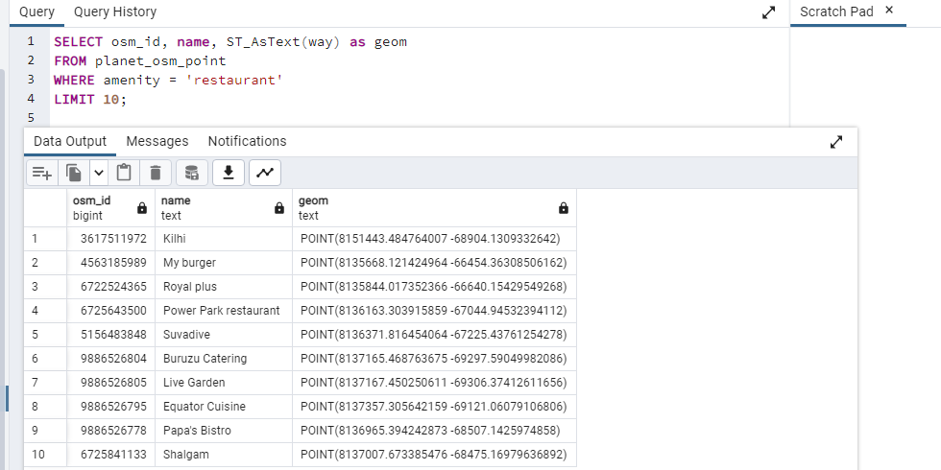

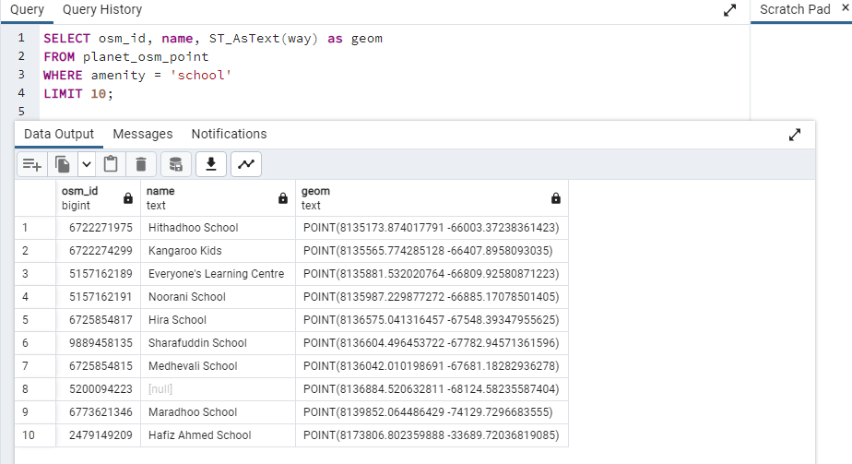

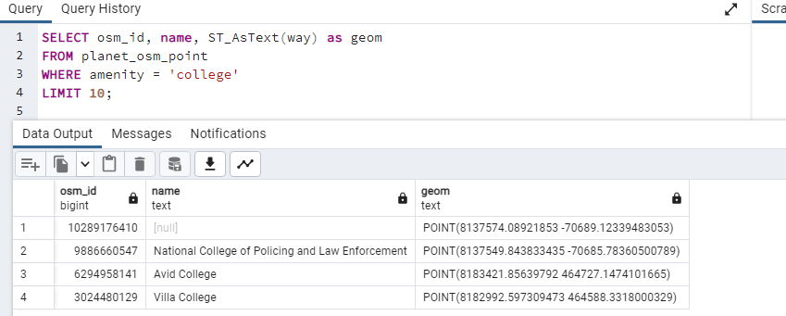

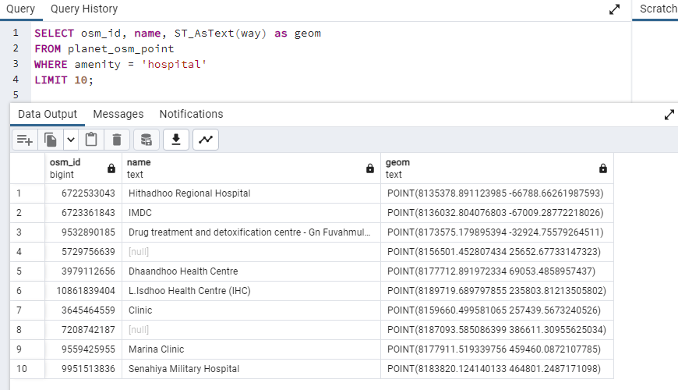

The osm_id, name, and way columns are chosen as geometry objects in text format in this query to indicate the restaurant's location. In order to reduce the number of outcomes to 10, we utilized the LIMIT clause to filter the results based on the amenity column, which represents the type of feature (in this case, a restaurant).

**Distance Calculation**

In order to determine the distance between two Maldives locations, we utilized the following SQL query:

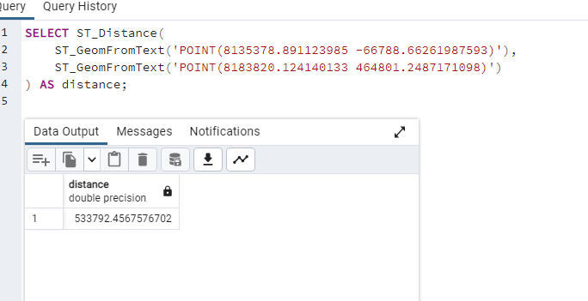

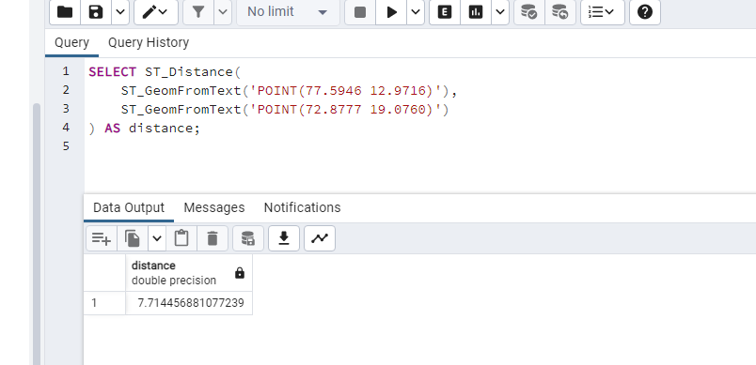

This program determines the separation between two Earthly locations that are identified by their longitude and latitude coordinates. The 'ST_Distance' PostGIS function, which determines the separation between two geometries, is used. The 'ST_GeomFromText' method is used to turn a point's textual representation into a geometry object. 'POINT(longitude, latitude)' is how the data is represented in text.

The 'ST_GeomFromText' function transforms the two points from text strings into geometry objects. The distance between these two geometries is then determined using the 'ST_Distance' function. 'Distance' is a column that contains the calculation's output. The distance is given in the same units as the coordinates of the input, which in this case are degrees. Other PostGIS functions, like 'ST_Transform' and 'ST_Distance_Sphere', can be used to change the distance's unit.

**Area of Interest Calculation**

This SQL query was used to determine the Maldives region of interest: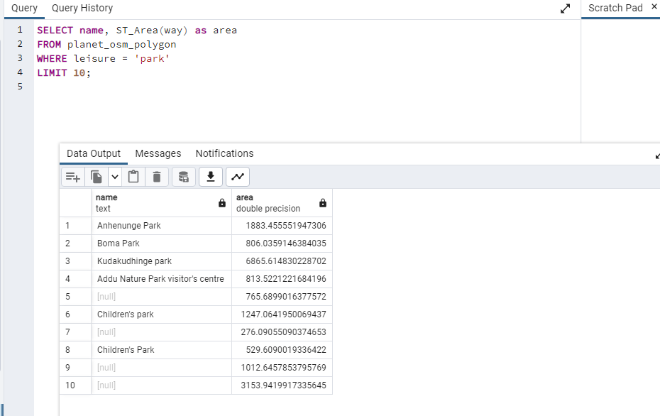

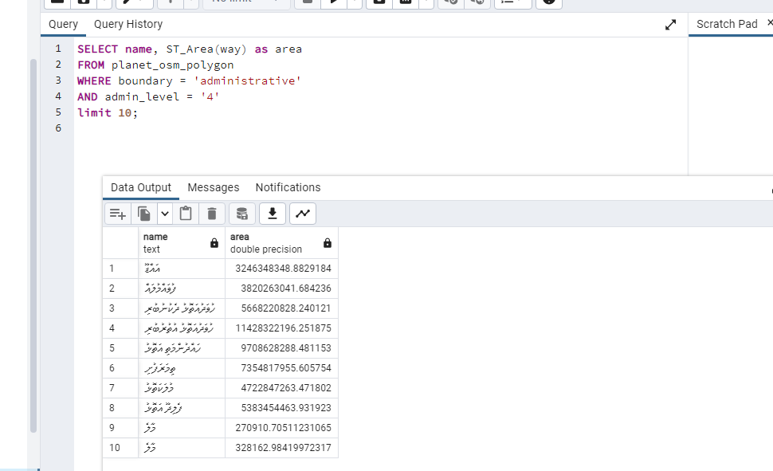

The planet_osm_polygon table, which holds details on polygons like land use areas, administrative boundaries, and buildings, is the source of the name and area columns in this query. Based on the border and admin_level columns, which show the type of polygon (in this example, an administrative boundary of level 4), we filtered the results. The ST_Area function, which returns the area in square meters, is used to calculate the area.

**Conclusion**

In this project, we used OpenStreetMap data to build a GIS analysis of the Maldives. We located certain features, determined the separation between points, and identified areas of interest. For the database and SQL queries to retrieve and analyze the data, we used PostgreSQL with the PostGIS extension. This project serves as an example of the effectiveness and adaptability of GIS analysis for comprehending and displaying geographical data.